Activity: Visualizing the AWS Global Infrastructure

Use the space provided to note key ideas and concepts.

Component | What Does It Do? | What Does It Consist Of?
Region | To achieve fault tolerance and stability, the regions are isolated from one another. It is not automatically replicated to other regions when it comes to resources. Whenever a data is store in a specific region, it is not replicated outside of the region. | The region consists of two or more availability zones. And there are 22 Regions of AWS.
Availability Zone | Availability Zones provides the ability to operate apps and databases that are highly available, fault tolerant, and scalable. It also helps build highly available apps, when an app is partitioned across Availability Zones companies are better isolated and protected from | There are currently 69 Availability Zones globally.  Availability zones consist of one or more data centers.
Edge location | To deliver content with lower latency. And ensure your user-facing data is transmitted securely and quickly worldwide. It also move your data away from the risks of the internet and place them in the protective walls of the AWS global network. | It allows for high availability and fault tolerance, as applications can be distributed across multiple AZs within the same region.

- How can Regions differ?
- Regions differ in their geographical scope and purpose. Each region is isolated from each other regions, and all physical locations are with independent power, cooling, and networking. It provides various key aspects including geographic location, services offered, compliance, and latency.
- How can the differences in Regions affect you?
- Choosing a region closer to the target audience reduces the distance data has to travel, resulting in lower latency and faster response times for application. This is crucial for user experience like gaming and real-time application. In addition, choosing your AWS region can impact the application’s performance, availability, and cost.
- What does latency mean?- It refers to the delay between user’s action and the response to the action. It is important when the time it takes for data to travel from its source to its destination and back to the user. The time it takes for data to travel or process to happen is the latency.
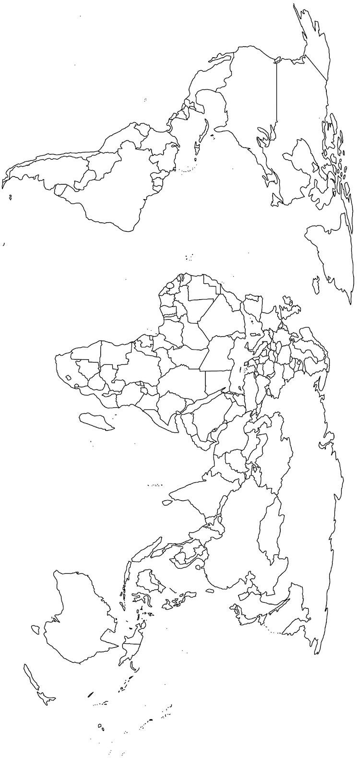

Draw a diagram of the AWS infrastructure around the globe. Label your diagram with the key terms: Regions and edge locations.
Edge Locations
Regional (Edge Caches)

